**18. LEISURE AND LIFESTYLE**

**1. PICTURE DESCRIBING**

Look at the pictures below. Talk about how people in the pictures usually spend their free time. Say why some people prefer spending their free time alone. Which traditional hobbies do the Slovak practice? Which sports do you practice as a hobby?

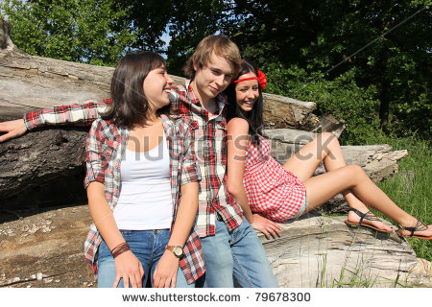 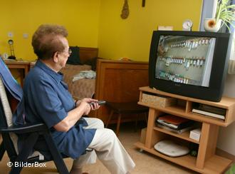 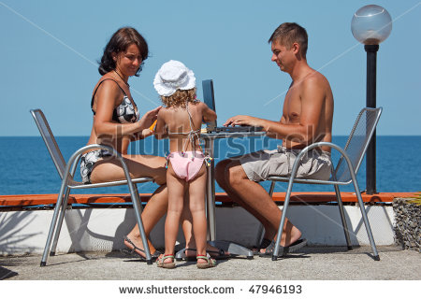

**2. DISCUSSION**

**What is leisure time?**

Free time after work or study is called leisure time. It is the time for fun, entertainment, going out or doing hobbies.

**Why are hobbies connected to lifestyle?**

Hobbies are connected to lifestyles. Some people like to be on their own and learn new things by reading books. Others enjoy company and often go out or do collective sports. Our hobbies should fit our character and complement well our work or study.

**What do teenagers do during their leisure time?**

Teenagers have their special leisure interests. These include playing team sports, dancing at a favourite disco, going to parties or joining some clubs. They like to spend their leisure time actively in groups, in good company. Those who prefer staying at home usually watch DVDs, listen to music, browse the Internet or chat on the Internet. Typical teenage sports are roller-skating and skateboarding. Many children and young people join different clubs where they practice their hobbies. The most popular are football, tennis, dance or horse riding clubs. Sometimes it is not their choice but the choice of their parents.

**Why do some parents tell their children what hobbies to practice?**

Some parents force their children to play an instrument or do some sport because they think they will prevent them from taking drugs or drinking alcohol.

**What are creative hobbies?**

Many people have creative hobbies, such as acting, choir singing, folk dancing and playing pop-music in amateur groups. Photography, painting and drawing are also popular hobbies. There are many opportunities for people to develop talents in these areas.

A lot of people, both children and adults, keep a pet. Older people like gardening, doing practical jobs around their house {DIY-do it yourself}, fishing, reading, going to theatre, concerts or art exhibitions. Slovak pensioners are quite their traditional and prefer staying at home.

**Which indoor and outdoor sports do people practice as their hobbies?**

At present, more and more people of all ages spend their leisure time doing exercises to keep fit. Hiking, cycling, rowing, playing golf and tennis are enjoyed by people all over the world. It is quite common to see parties of hikers, cyclists or rowers spending their weekends outdoors. Those who prefer indoor physical exercises, such as body buildings or aerobics, go to fitness centres. A relatively recent sport enjoyed by the young is snow-boarding which combines skiing, surfing and skateboarding. Many Slovaks travel abroad to practice less common sports, such as scuba diving, yachting and playing golf.

**3. SITUATION TASKS**

**TASK 1 Which of the following hobbies are individual, collective hobbies or both?**

*collecting stamps dance skateboarding horse riding playing the piano*

*choir singing aerobics body building gardening reading tennis*

*hiking photography DIY yachting*

**TASK 2** **Which hobbies would you recommend to these people? Which hobbies would you not recommend them? Explain the reasons of your choice.**

***Example* a young businessman who loves adventure and fun**

*I think that* this person should practice some adrenaline sports, such as scuba diving or yachting. These are adventurous sports and they will bring him/her a lot of relax and fun in a team. *I do not think that* he or she would be interested in something like collecting stamps. I think it would be boring for him or her.

1. a bored teenager who likes movement, fun and company of friends

2. a talented girl who likes singing

3. an older man who works physically a lot

4. a middle-age women who wants to lose some weight

5. a pregnant woman

6. the only child who feels only

**ROLEPLAY** (**you** as a trainer and **a mother**)

*A child is found to be a very talented gymnast at school. You, as a trainer want to convince the parents that the child should go to a special sports school for talented children. You think that this is a great opportunity which should not be missed. The child is very talented and could have a great future. But to be successful, it is important for the child to go to the special school and begin training at once. Its mother is against the idea. She does not think the child should change schools. She knows that, even though her child is undoubtedly very talented, very few children actually make it to the top and the chances of real success are very limited. In her opinion, it would be better to wait until the child finishes the school and then make a decision.*

Mr a Mrs... I want to tell you something. How should I say this? You know, I think that..., O.K it is about your child. Well, I am convinced that.... I’ d rather....I would prefer .....I hate. I promise I will ....I’d like to.....

**TASK 3**

Leisure time is a time after school or job. It is time for fun and entertainment, relax and hobby. What are the most traditional ways of spending free time?

What do you do in your free time? Do you go to a school club and join the after-school activities? What possibilities do you have?

Do you work in your free time to earn some extra money? What opportunities do students have to get a part-time job?