**17. FOOD**

**1. PICTURE DESCRIBING**

Look at the pictures and discuss when to eat such food and why. Compare how you eat to what people say is healthy. What is your favourite food ? Who are vegetarians? What should people do to stay healthy?

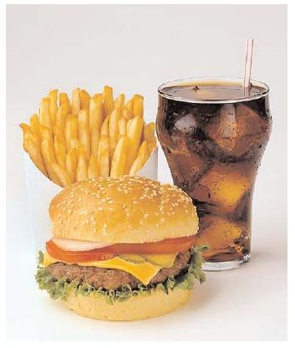 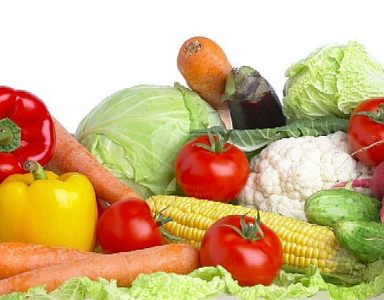 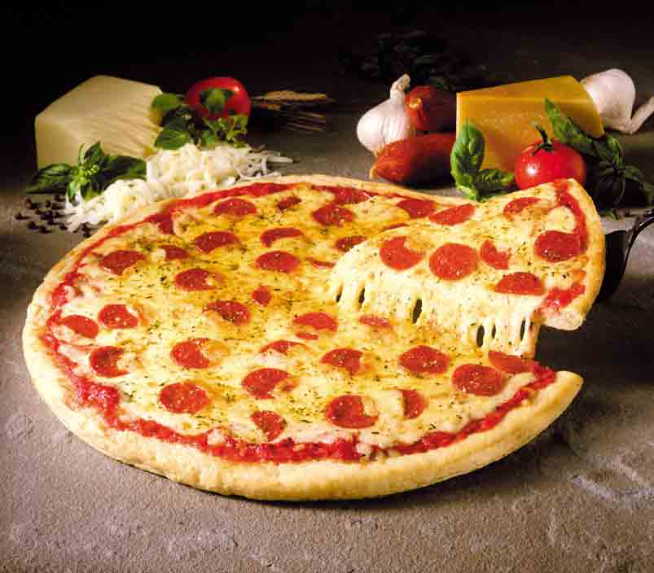

**2. DISCUSSION**

**What do the Slovaks have for lunch?**

Normally, we eat three times a day – we have breakfast, lunch and dinner. Eating habits depend on the lifestyle of people. Busy mangers do not eat regularly, young people often choose fast food, women who want to lose weight eat as little as possible and kids are often fussy about their food.

**What do the Slovaks usually have for breakfast?**

Slovaks usually have bread with butter, jam, honey, ham or cheese for breakfast: some prefer scrambled eggs or sausage.

**What does the traditional English breakfast consist of?**

The English usually begin the day with a cup of tea of coffee. The traditional English breakfast starts with cereals – porridge or cornflakes. This is sometimes followed by fried bacon and eggs or sausages with fried tomatoes, often on the weekends.

**What do the Slovaks have for lunch?**

In our country lunch is the main meal consisting of soup, a main course with a side dish and a dessert. Slovaks like to eat meat, usually, pork, beef or poultry with potatoes and rice. *Bryndzové halušky* {gnocchi with sheep cheese} is considered a Slovak national meal. Hungarian cuisine, typical for spicy meals, is quite popular in the southern parts of Slovakia. Italian cuisine, mostly pizza and pasta, has become very popular in our country and it is prepared to traditional Slovak meals in many restaurants. Schoolchildren have lunch in canteens. Businessman eat in restaurants where a daily menu at reduced prices if offered during lunchtime.

**What is the mean meal of the day for the English and the American? What are typical eating habits at dinner in Slovakia and in Britain?**

In Britain, lunch is a light meal consisting of a warm dish {rarely soup} and a dessert, or just sandwiches, some fruit, pudding or ice cream. Beef, chicken or lamb is served with potatoes, vegetables and gravy. Many Americans like to have lunch and dinner “out” – at snack bars, fast food restaurants or expensive hotels. They also use take - away services. Dinner, the mean meal in Britain and America, is served in the evening at between 6 and 7 o’ clock when all the members of the family are at home. This meal is often eaten in front of the television. Most dinners during the week are simple, often using pre-cooked food with frozen vegetables, which can be heated quickly. The Slovaks prepare dinner themselves at home. It is either a warm meal or a sandwich. Sometimes they order pizza. Some people have a light supper, often cheese and biscuits and a glass of milk or a mug of cocoa before going to bed.

**What are take away services?**

Typical take away food includes pizza, Chinese food and the traditional fish and chips

**3. SITUATION TASK**

**TASK 1 Which food or meals below do you eat for breakfast, lunch and dinner?**

bread roll, sausage, garlic soup, cornflakes, chicken with rice, pizza, cake, bread and butter, scrambled eggs, ham and eggs, sandwich, cabbage soup, ice cream, fish and chips, tuna salad, fried bacon, vegetable salad, pasta, beef with potatoes, cheese, lentil soup, French fries

**TASK 2 Answer the following questions**

Why do people use fast food or self-service restaurants?

What is your main meal of the day? What time is it eaten? Do you eat anything between meals? How many courses does your lunch consists of? Is there any special meal you would offer to your foreign visitor? Could you describe how you would prepare it?

What do children usually eat for dinner? What should children eat? What do you usually eat?

**Can you explain the term junk food?**

*Lollies, soft drink, potato chips, hot chips, ice cream, and hamburgers, hot dogs and other kinds of take away food are called junk food. This kind of food has too much fat in it. It has too much salt in it too. It has too much sugar. It is O.K to eat a little bit, but too much is not good.*

Do you often go to the restaurant? When do you go there? On which occassion would you go there? What can you order in a restaurant?