1. FAMILY
TASK 1
Look at the pictures and describe the families. Then compare them with living in the past and nowadays.
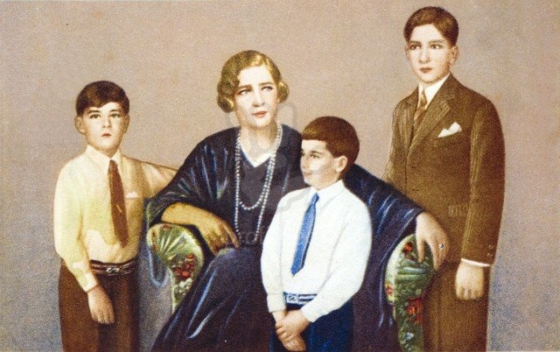 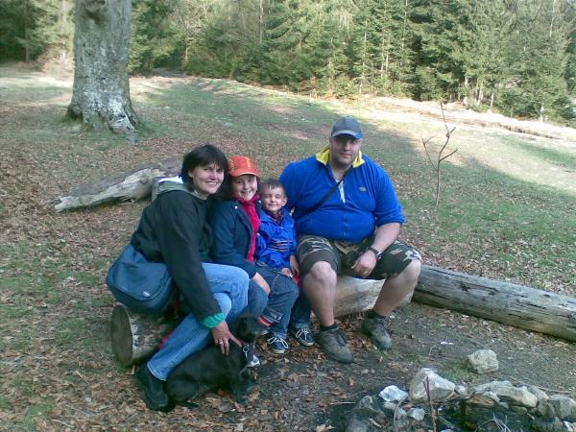 Family in the past Family in the present

Family in the past and in the present
In the past there were big families. Grandparents, parents and their children were living together for a long time. The education was very strict. The children had to obey their parents and grandparents. Women usually got married very young sometimes without being loved in the future husband. The main reason was wealth and possession and having a lot of children. Nowadays, the situation is another. There are small families instead of big families. People have few children than in the past. The education is not so strict, women needn’t get married so young and they can get marry the man they really love.

Describing of the picture
In the first picture is the family in the past. I can see a mother and her three children. The mother is tall, she has got short fair hair and she is sitting in the armchair. The children around her are three boys. Each of them is behaving very politely and standing straight. The age of the boys is between eight and thirteen. They are the school boys.
In the second picture is a typical family on a trip in the nature. Father, mother and their two children. They are sitting on the trunk of the tree. They are really happy because they enjoy being together. It’s very nice weather, the sun is shining. Maybe they are going to have a barbecue.

TASK 1
1. What does the word family mean? How would you define the word family?
A family is a social unit, consisting of mother, father and children living together in one home. It is the most important social group.
A family means for me most of all a feel of safety and protection, socialization and education.

2.What are the main functions of a family?
The family is the basic social unit. It supplies basic physical, economic and emotional security for its members. Human needs, such as love, protection, responsibility and support are fulfilled there.

3.What are the main roles of children and parents in a family?
All family members have specific social roles with various duties and responsibilities. The women usually do domestic chores, such as cooking, shopping, cleaning and ironing. The men usually do such activities such as cutting the grass, repairing, cleaning the car or sometimes taking out the rubbish.
The main role of parents is to raise their children. Parents should teach how to differentiate between good and bad, how to solve problems in life and how to care about others.
The main duty of children is learning and going to school and also helping their parents with some housework.

4. What are the main reasons for divorce?
The common reasons are different interests, luck of faith and trust, financial reasons, living with parents and parents –in-law, addiction to alcohol, drugs, gambling, such as slot machines and unemployment.

5. How is a family life in Slovakia?
Family life is different all around the world. In Slovakia many families get together for various occasions and anniversaries, such as birthday, graduations, weddings, christening and confirmation parties, church feast and funerals. Slovak families are known for their hospitality.

TASK 1

- Describe your own family. When do you usually get together? Describe one of your grandparents – their appearance, personality, lifestyle, clothing, habits, hobbies and explain his or her role in your family?

- How do you imagine your future life partner? Do you want to get married? Why? Why not?

TASK 2

Role-play
Your sibling usually takes your favourite clothes. You don’t like it because you care about your things very much. You decided to speak with him/her about it openly and are not ready to make any compromises. What do you say him or her?

I usually say him or her if he or se could give me my favourite CDs back to me. I try to explain him or her that everyone has its own stuff and things. Stealing or taking the thing is not a solution. I sometimes can lend him or her my favourite things but he or she must give them back to me. They are part of my life and I like them very much.

VOCABULARY

Members of the family

Childhood
- newborn
- infant dojča
- toddler batoľa
- youngster
Adulthood
- engaged couple
- fianceé, fiancé
Married life
- married couple
- daughter –in-law
- son-in-low
- sister-in-law
- father –in-law
Parenthood
- mother
- father
- son
- daughter
- foster child/parents adoptívne dieťa
- stepmother/father
- mother –in-low
- father-in-low
Old age
- grandparents – grandfather{daddy}, grandmother{granny}, grand grandparents
- grandchild – grandson, granddaughter
- pensioner
Family members
- aunt
- cousin
- nephew
- niece
- uncle
Other words
- an only child
- orphan
- widow, widower
- divorce sb.
- get divorced from
- get engaged to
- get married to, marry sb.
- give birth to
- grown –up
- half-sister/brother
- sibling
- maternity leave

