**8. EDUCATION**

**1. PICTURE DESCRIBING**

**What is your favourite subject at school ? Do you like going to school? What school do you attend? Which year are you in?**

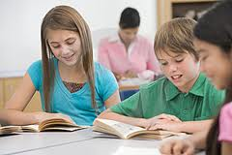 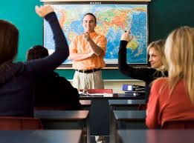 

**elementary education secondary education high schools**

**TEXT**

Good education is very important for a successful life. In Slovakia school attendance is compulsory from the age of 6 to 16. After nursery schools and kindergartens, children start to attend an elementary school at the age of 6. When they are 16 they can decide to leave the school with an elementary qualification or to continue to a secondary school. Pupils usually have to pass entrance exams to continue their studies at secondary schools. The best students apply for study at a grammar school{or high school} called *gymnasium,* which prepares for university study.

There are different types of secondary schools which usually take 4 years, the most popular are secondary business schools, technical schools and medical schools. Vocational schools and their training centres prepare students for different kinds of professions. The study last either 3 years and it ends with achieving a skill certificate or 5 years which ends with a school-leaving exam called *maturita*. Some subjects are compulsory, others are elective. Students at vocational schools must take a theoretical and practical exam from their specialised subjects too. After finishing study at secondary schools, students can get a job or apply to study at university. In most cases, they have to take an entrance exam to get in. A study at university takes 5 or 6 years and finishes with graduation where graduates are given diplomas to their majors.

Student’s schedule and school subjects differ from school to school. Vocational students must also take some practical lessons outside their schools, called **the practice.** A school year in Slovakia starts the first week of September and finishes the last week of June. In between, there are a few days off{for example at All Saint’ s Day, Easter or the May days}. There are winter holidays, which last about two weeks and spring holidays, which last one week. The summer holidays are the longest and last two months.

Extracurricular activities are very popular in the afternoons. There are many different clubs a and sports teams at schools which meet after the classes. Many schools publish their own student newspapers and some have their own radio stations. Most schools in Slovakia have their own gym, school canteen and sometimes a swimming pool, school playground and language schools.

**2. DISCUSSION**

**1. How long is compulsory school attendance in Britain and in Slovakia?**

In Slovakia school attendance is compulsory from the age of 6 to 16, British children begin their education at the age of 5 and must attend school to the age of 16.

**2. What kind of schools are in Britain? What do you know about the British public schools?**

In Britain there are state schools and private schools {called public schools}. The majority of British children are educated in state schools which are free of charge. There are many private schools in Britain, mainly for the 11-18 age group. Public schools are private boarding schools which are peculiar to Britain. The fees are very high. The most exclusive ones, with a long tradition, are Eaton or Winchester.

**3. How are the British children educated?**

Children in Britain continue to study at a secondary school, called a comprehensive school, which offers a general education. This ends at the age of sixteen, when most pupil take some form of public examination in about seven subjects. These *General Certificate of Secondary Education* exams are national and give pupils a qualification that is recognized across the whole country. Most pupils continue their education at college or university. The most famous universities in Britain are *Oxford University* and *Cambridge University*.

**3. SITUATION TASK**

**Try to give advice to a friend who**

* **has failed his exam**
* **wants to learn English**
* **is always using cribs when writing tests**

**Express your opinion. What are the qualities of a good teacher? What are the qualities of a goof student? Talk about them and use the following adjectives.**

*I think…., In my opinion…., According to some people….,*

*A good teacher, a good student should/shouldn’t be…, must/mustn’t be…*

Strict fair tolerant responsible liberal authoritative creative informed interested clever educated easy-going interesting friendly hard-working

**Now agree or disagree with the folowing statements. Use the sentences to develop discussion about them.**

***Good education is important for successful life. Students should not be given any homework.***

***There should be no tests and exams at schools. Summer holidays should last three months.***

To agree: To disagree:

I agree. Exactly. Absolutely. That’s true. Yes, but., I am not sure. I don’t think so.

**Give a short presentation about your school to the 9th graders from elementary schools. Finish the following sentences:**

Open the presentation: Dear pupils, welcome to our school. My name is … and I want to tell you something about studying at {name of your school}.

Give the presentation: In our school, there are about{number of students}. We all study hear to become {your future job}. We learn different subjects here. The most favourite subjects are{say which ones}. The least favourite subjects are…..because they are…..There are most{boys/girls} here which is bad/good because{say why}.{Say how often}, we have practical lessons where we practice our skills for future jobs. We often go to{say where} to do our practice. In the afternoons we often meet{say where} where we{say what you do there}.

Close the presentation: At the end I can say what I like studying at our school. There is a lot of fun. Thank you for your attention.

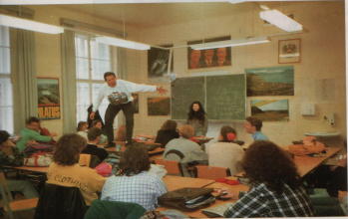**Discuss the following questions:**

What kind of speech is the student on the desk giving?

What kind of teacher-pupil relations might there be? (friendly/ unfriendly, respectful, formal / less formal, showing or feeling respect…)

Are you satisfied with how discipline is kept at your school? Give examples and say what you would change. Could an incident like the one in the picture ever happen in your school? Why? / Why not?